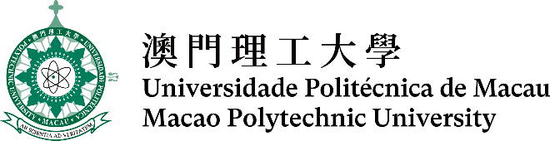

第十五屆全澳資訊科技大賽 - 三維編程及動畫比賽
The 15th Macao-wide IT Competition -
3D Programming and Animation Contest
說明文檔Documentation

組別：  Category: | 中學組Secondary ☐ 公開組Open ☐
動畫作品標題：
Title of Animation:
参賽隊伍成員（2-3）：
Team members (2-3):
動畫執行時間（秒）：
Animation playtime (in seconds):
開發平台：  (Development platform): | Alice 3.x ☐ Unity ☐  Blender ☐ Autodesk 3ds Max ☐
以下中學組適用 (Applicable to Secondary Category)
學校：
School:
指導老師：
Mentor:

序言／背景 Introduction/Background
故事的表達 (例如主題匹配度、故事完整性、作品整體意念等)
Story telling (Such as match of the theme, story completeness, overall idea of the work, etc.)
技術複雜性 (例如編程、三維建模和動畫、影片呈現和三維效果等)
Technical complexity (Such as programming, 3D modelling and animation, video presentation and 3D effects, etc.)
創意（例如表達、技術、多媒體等）
Creativity (Such as expression, techniques, multimedia, etc.)
團隊合作 Teamwork
不屬於參賽者本身所創作及擁有的外置多媒體（圖形、聲音、三維模組）的來源
Sources for any imported media (images, sounds and 3D models) not produced and owned by the participants
其他註釋 Other Comments

