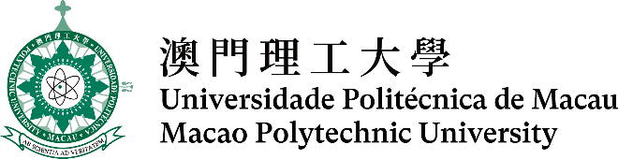

**第十六屆全澳資訊科技大賽 - 三維編程及動畫比賽**

**The 16th Macao-wide IT Competition –**

**3D Programming and Animation Contest  
  
說明文檔及原創作品聲明**Documentation and Declaration of Original Work

|  |  |
| --- | --- |
| 組別： Category: | 公開組Open ☐  中學組Secondary school ☐ |
| 動畫作品標題： Title of Animation: |  |
| 參賽隊伍成員（2-3）：  Team members (2-3): |  |
| 動畫播放時間（秒）：  Animation playtime (in seconds): |  |
| 開發平台：  (Development platform): | Alice 3.x ☐ Unity ☐  Blender ☐ Autodesk 3ds Max ☐ |
| 以下中學組適用 (Applicable to Secondary School Category) | |
| 就讀學校：  School: |  |
| 指導老師姓名（確認指導）：  Mentor (Confirmed): |  |

|  |
| --- |
| 序言／背景 Introduction/Background |
|  |
| 故事的表達 (例如主題匹配度、故事完整性、作品整體意念等) Story telling (such as match of the theme, story completeness, and overall idea of the work) |
|  |
| 技術複雜性 (例如編程、三維建模和動畫、影片呈現和三維效果等) Technical complexity (such as programming, 3D modelling and animation, video presentation, and 3D effects) |
|  |
| 創意（例如表達、技術、多媒體等） Creativity (such as expression, techniques, and multimedia) |
|  |
| 團隊合作 Teamwork |
|  |
| 不屬於參賽者本身所創作及擁有的外置多媒體（圖形、聲音、三維模組）的來源  Sources for any imported media (images, sounds and 3D models) not produced and owned by the participants |
|  |
| 其他註釋 Other Comments |
|  |
| 確認知識產權及原創作品聲明 Declaration of Original Work |
| |  |  | | --- | --- | | 聲明人 (參賽成員代表) 簽署： Signed by team member representative |  |   2024年_____月______日於澳門 2024 - - , Macao |