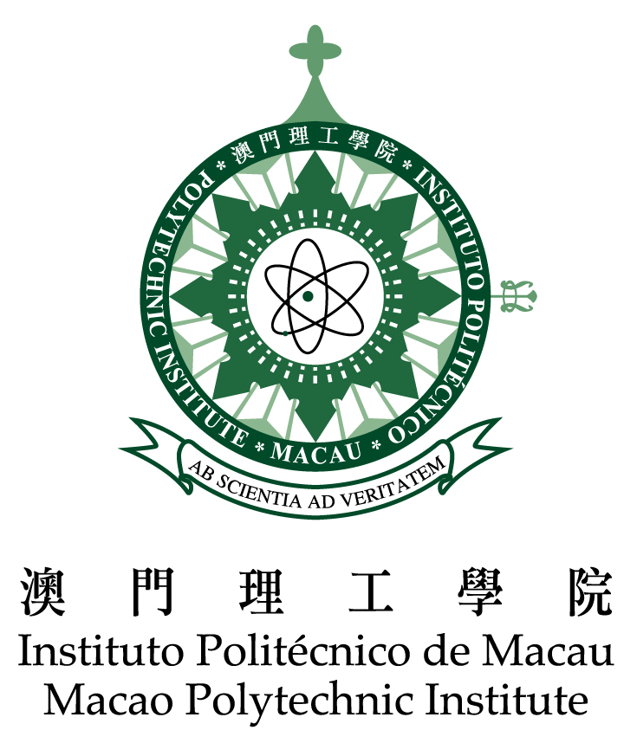
Macao Polytechnic Institute Open Day 2011
26th February, 2011

Venue: Rua Luiz Gonzaga Gomes, Macao Polytechnic Institute
Inquiry: Tel: 8599 6116/ 8599 6132

Time | Activity | Venue
14:00-18:00 | Presentation of Academic Buildings and Facilities  (Campus Tour every 30 minutes) | Main Campus
14:30-17:00 | Sports Biomechanics Lab (Open for public fitness test) | P116, MPI Multisport Pavillion
14:30-17:30 | Tchoukball & Basketball Performance | MPI Multisport Pavillion
15:00-17:00 | Music Performance | 4 FL, Ming Tak Building
15:00-17:00 | Scratchboard workshop & Art Work Display | 4 FL, MPI Complex
15:00-17:30 | Sharing of IT Education and Research Experience | Academic Buildling-A, 3 FL
15:00-17:00 | Presentation of School of Health Science (Laboratory Demontration) | 7 FL,8 FL, Ming Tak Building
14:00-14:45 | Presentation Concerning IELTS – International English Language Testing System & BULATS – Business Language Testing Service | Auditorium
14:45-15:00 | Opening Ceremony | Auditorium
14:45-15:00 | Presentation of School of Business | Auditorium
15:00-17:00 | Presentation of School of Public Administration  Presentation of Presentation of School of Language & Translation  Presentation of the School of Art  Presentation of the School of Physical Education and Sports  Presentation School of Health Sciences | Lecture Theatre1  Lecture Theatre 2 Lecture Theatre 3  Multisport Pavillion P107  M607, Meng Tak Building
14:00-18:00 | Display Exhibit by Division for Research and Publications | 2nd FL , Auditorium
16:30 | Introduction of Jointly Offered Postgraduate Diploma Programmes | A107, Chi Un Building
15:15 - 16:45 | Shuttle Bus to Gaming Teaching and Research Centre (Every 30 minutes) | Reception, Wui Chi Building

